Name: ____________________________ Mark: _________/44

APPLECROSS SENIOR HIGH SCHOOL
UNIT 1 & 2 PSYCHOLOGY
TEST 1 - 2015

FOR ALL QUESTIONS REQUIRING CALCULATIONS – ALL WORKING OUT MUST BE SHOWN OR MARKS WILL BE DEDUCTED.

1. Name three (3) ethical factors that a researcher in psychology needs to take into account when experimenting on human subjects. Explain the necessity for each one.

(6 marks)

2. An experiment was carried out to test the difference between individuals with autism and non autistic individuals’ emotion perception skills. This was done by testing participants’ ability to recognise emotions from photographs that revealed only the eyes.

Below is a table showing the mean scores of autistic and ‘normal’ participants’ ability to recognise emotions from a person’s eyes. The maximum score possible was 25 and if a participant simply guessed the score should be 15.

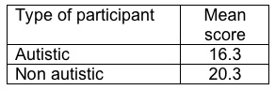

(a) Identify the independent variable in this experiment. (1 mark)

(b) Identify the dependent variable in this experiment. (1 mark)

(c) Correctly phrase a hypothesis on this experiment. (2 marks)

(d) In an experiment, a control group is often used. Explain the difference between a control group and an experimental group. (2 marks)

3. (a) Name three non-experimental data collecting techniques. (3 marks)

1.
2.
3.

(b) Choose one of your responses for part (i), and describe one advantage and one disadvantage of that particular non-experimental data collecting technique.
(2 marks)

Non-experimental data collecting technique: ________________________________

Advantage
Disadvantage

4. A researcher has conducted a study to investigate the relationship between how good people think their memory is, and how well they actually do on a memory test. The first variable was ‘self-rating of memory’ and was measured by asking people to rate their memory on a 10-point scale (where 1 = very poor and 10 = excellent). The second variable was ‘actual memory’ and this was measured by showing them a video of a minor road accident and asking them a series of 10 eye-witness questions.

Results were as follows:

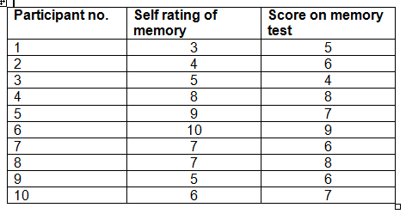

(a) On the grid below, sketch an appropriately labelled scattergraph displaying the results. (4 marks)

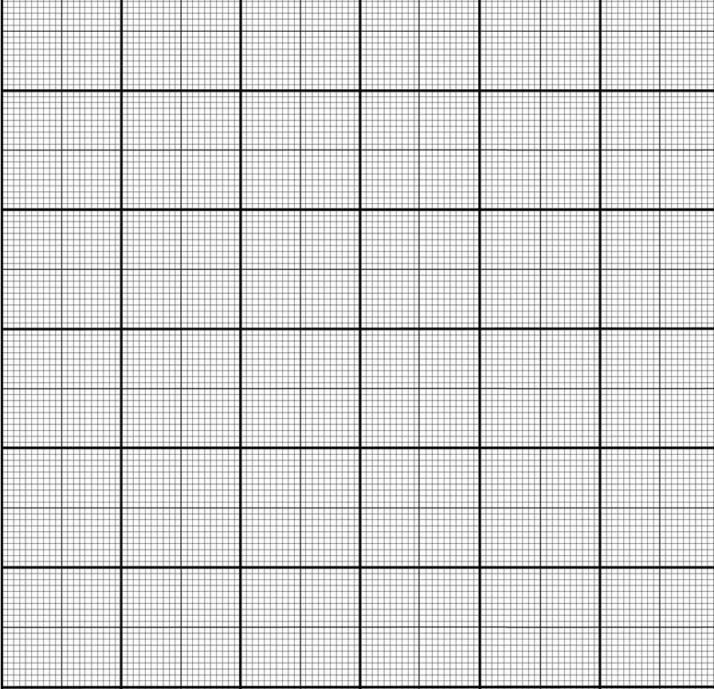
(b) (i) Give an approximate correlation co-efficient (number) that describes the trend in this data.
(1 mark)

(ii) Interpret and describe in words the correlation co-efficient you wrote for the question above. (2 marks)

(c) Using the “Self-rating of memory” data, calculate the:
(i) mean
(ii) mode
(iii) median
(iv) range
(7 marks)

5. The following statistics were reported by people who had suffered from one the disorders listed in the table below in the last 12 months. (Aust. Bureau of Statistics, 2009)

 | Anxiety Disorder | Mood Disorder | Substance Use Disorder
Women | 18% | 7.1% | 3.3%
Men | 11% | 5.3% | 7.0%

Usually people will have more than one disorder. They are said to have co-morbidity. What is the probability of a man having both an anxiety and mood disorder in the past 12 months?

(2 marks)

6. Study the graph below.
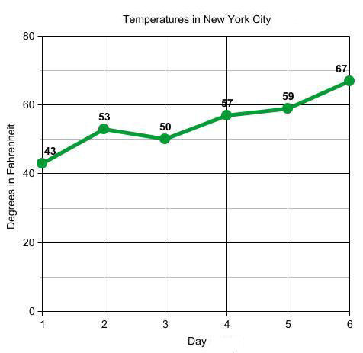

Put the data displayed in the graph above into a table formatted to APA standards.

(4 marks)
7. Explain the difference between the RELIABILITY and VALIDITY of data.

(2 marks)

8. Give one reason why would you choose to collect qualitative data?

(1 mark)

9. Complete the diagram that outlines the steps of the scientific method.
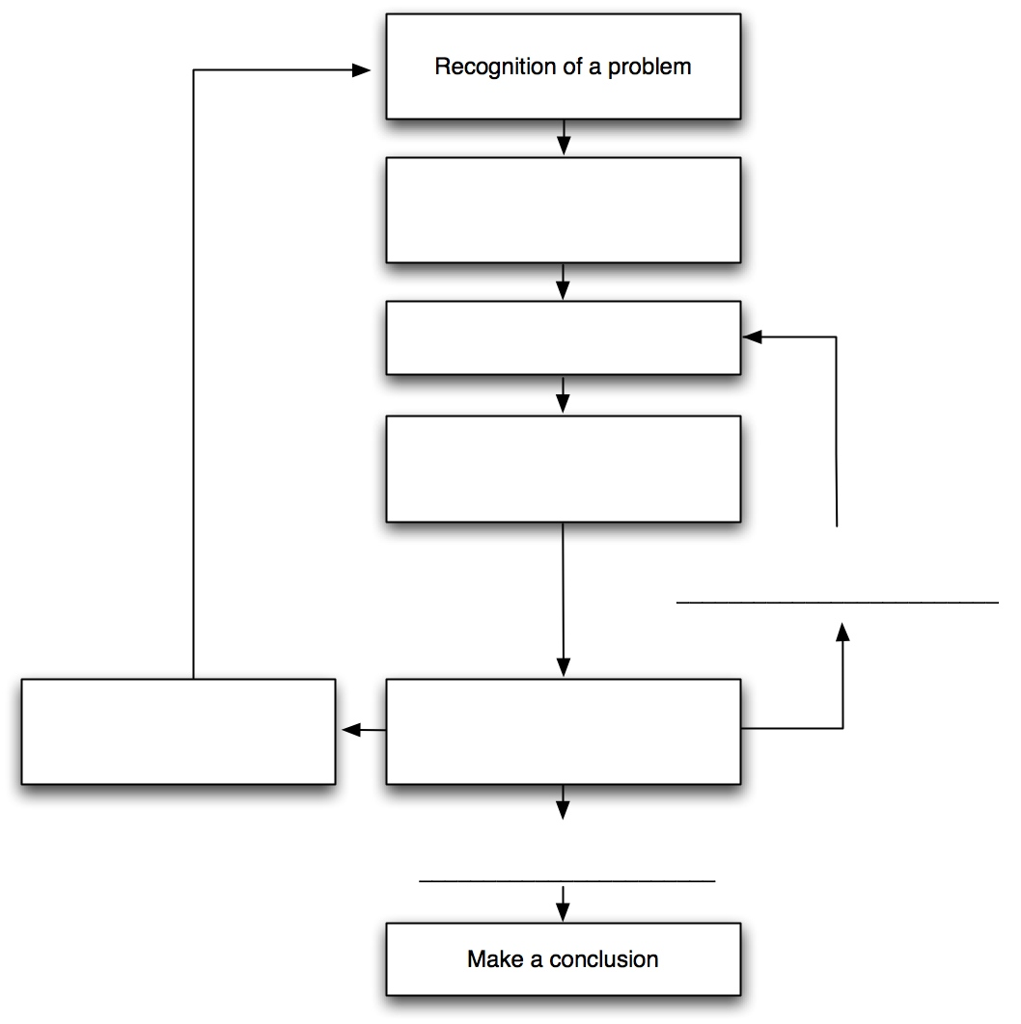

(4 marks)

